**Name: Abdelrahman Mohamed Ahmed Mahmoud**

**ID: 20170148**

**Group : 6**

**under supervision of : Dr. Abdulhadi Nabih**

**Math’s Assignment**

**Maclaurin Series**

A special case arises when we take the Taylor series at the point 0. When we do this, we get the Maclaurin series. The Maclaurin series is the Taylor series at the point 0.

A Maclaurin series is an expansion series of a function, where the approximate value of the function is determined as a sum of the derivatives of that function. The Maclaurin series is a special case of the Taylor series where the function is expanded around zero, rather than some valuehttps://cramster-image.s3.amazonaws.com/definitions/calc-67-eq-1.gif. It assumes that f(x) can be written as a power series around https://cramster-image.s3.amazonaws.com/definitions/calc-67-eq-2.gif and has determinable derivatives of all orders. In a Maclaurin

https://cramster-image.s3.amazonaws.com/definitions/calc-67-eq-3.gif

Series, every term is a non-negative integer power k of the variable x, with coefficient.

https://cramster-image.s3.amazonaws.com/definitions/calc-67-eq-4.gif

For a function f(x), the Maclaurin series is given by.

Maclaurin series for any polynomial is the polynomial itself.

It is used to calculate many functions like trigonometric functions and logarithmic functions and many by simple way that could be implemented by the machines.

**Value of X**

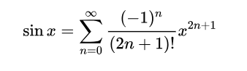

**X to radians**

**Put X in the formula**

**Sum=0**

**n=0**

**n<10**

**FALSE**

**TRUE**

**n+=1**

**Print Sum**

**Sum+=sin(x)**

**Value of X**

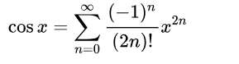

**X to radians**

**Put X in the formula**

**Sum=0**

**n=0**

**n<10**

**FALSE**

**TRUE**

**n+=1**

**Print Sum**

**Sum+=cos(x)**

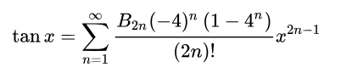



**Print Sum**

**Sum=sin(X)/cos(X)**

**X to radians**

**Value of X**

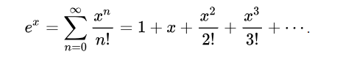

**Value of X**

**Put X in the formula**

**Sum=0**

**n=0**

**n<10**

**FALSE**

**TRUE**

**n+=1**

**Print Sum**

**Sum+=e^x**

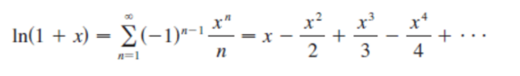

**Value of X**

**Put X in the formula**

**Sum=0**

**n=0**

**n<20**

**FALSE**

**TRUE**

**n+=1**

**Print Sum**

**Sum+=ln(1+x)**